 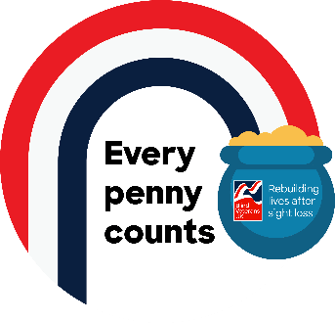

**Every Penny Counts – Design Ideas**

So you’ve downloaded your label template. What will you do with it next?

Here are some ideas to help you decorate the black and white label template or perhaps use it as inspiration to create your own design from scratch.

Many of these ideas have been inspired by previous projects our veterans may have taken part in within our National Creative Project – a project that connects our veterans remotely and gets them involved in group activities from their homes. We deliver activity packs right to our veterans' doors. Right now, we are offering art and craft, written and spoken word, and gardening activities, among others.

**Mosaic collage**

Mosaic is an artform where patterns or designs are made up of tiny irregular tiles. Why not try making your own tiles out of pieces of scrap paper? Gather left over wrapping paper, magazines, catalogues and junk mail. Find the colours you which to use and tear or cut into small squares. You can then play around to create your own tile pattern to place inside the template design.

**Add some colour**

Younger supporters might like to practice their colouring or painting technique and older supporters who enjoy a bit of adult colouring could use felts, crayons or paints to simple colour the template.

**Dot art**

Want to do something directly onto the carton? Acrylic paint can be a simple way of transforming recycled cartons into something new. You don’t need fancy tools and brushes. You can use anything pointed – a toothpick, the end of an old pen, or a paintbrush to try dot work. Use this technique to copy the template directly onto the carton. Swap Acrylic for poster or water-based paints and try this technique to paint directly onto the template.

**Glitter art**

Gather glitter and glue to add some sparkle to the template. Add one colour at a time, waiting for the glue to dry before adding the next to keep your design crisp and clear. Don’t forget to put a tray or piece of newspaper under your template to catch excess glitter and make clear up easy!

**Découpage**

This is the art of decorating an object by gluing paper cutouts in layers. As more layers are stuck on and the glue dries like a varnish, this will create a unique effect. Simply tear strips of wrapping paper cuttings, magazines, or old tissue paper. Water down some PVA glue and cover your carton – leaving each layer to dry before adding a new one.

**Get Digital**

Use programmes on your electronic device to create your own version of our label. [Download our Every Penny Counts logo](http://www.blindveterans.org.uk/support-us/fundraise-for-us/do-your-own-thing/give-me-some-ideas/power-up/sign-up-to-power-up/thanks-for-signing-up-to-every-penny-counts/#resources) to use in your design.

**We’d love to see your finished Every Penny Counts coin collection carton.**

**Join your** [**Regional Blind Veterans UK Facebook group**](https://www.blindveterans.org.uk/news-stories/#groups) **and share pictures of your upcycled carton or share via your own social media accounts. Don’t forget to** [**follow and tag us**](https://www.blindveterans.org.uk/news-stories/#follow)**!**

**Alternatively please send your images to** [**fundraising@blindveterans.org.uk**](mailto:fundraising@blindveterans.org.uk)

**Thank you for taking part!**